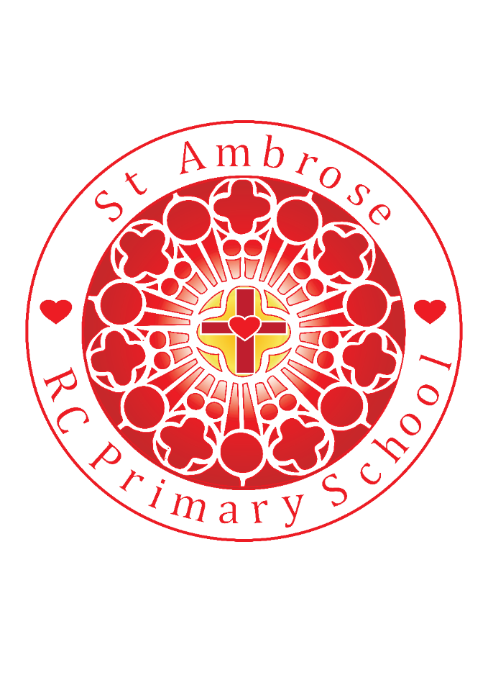

St Michael’s RC Primary School Weekly Newsletter

Loving Valuing Respecting

Diary dates

**After-school Sport**

3/9 - 21/12**:**

**Tu** Y5/6 Football

**Th** Y3/4 Multi skills

**December 2018**

**We 12th**  EYFS Performance 9:30am

**Th 13th**  KS1 Performance 2:15pm

**Fr 14th** PTA Christmas disco

**Mo 17th** KS2Christmas story 2:15pm

**Tu 18th** Christmas meal in Christmas Jumpers

**We 19th** Mini Vinnies prayers in Church

**Th 20th** Party afternoon

**Friday 14th 1.30pm Advent service at St Michaels for Y3 children from St Bernadette’s and St Michael’s**

**Tuesday 18th Dec – Y4 will be watching the Y4 Nativity at St Bernadette’s**

**Whole School Mass at 9.15am on Friday 21st December – All Parents and Families welcome.**

**Advent Exposition in Church**

12th & 19th December 3.15pm

Pupil of the week – Well done!

R: Ted O’C for fabulous creative skills making an aeroplane

Y1: Marceli T for enjoying writing so much

Y2: Hannah J for a fantastic story about the Alien on the moon

Y3: Oliver L for writing a brilliant story and focusing on his handwriting

Y4: Erin T for producing an imaginative Roman Mosaic

Y5: Evie B for an excellent interpretation of William Hunt’s ‘Light of the world’ painting

Y6: Joseph K Being a gentleman with excellent manners

Lunchtime Superstars

N: Poppy D

R: Georgia H

Y1: Olivia U

Y2: Austin B

Y3: Brandon L

Y4: Ollie R

Y5: Philip L

Y6:Grace J

Well done to everyone!

**NEWS**

Friday 7th December 2018

Dear Parents,

[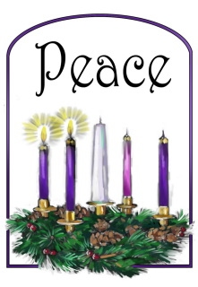](http://www.google.com/url?sa=i&rct=j&q=&esrc=s&source=images&cd=&cad=rja&uact=8&ved=2ahUKEwi67v_cn43fAhUC6RoKHda6C5gQjRx6BAgBEAU&url=http://stingersgrade3.weebly.com/class-blog/advent-week-two-candle-of-peace-and-preparation&psig=AOvVaw0bE7R2qGEY4YjScr_DEF8B&ust=1544255911833730)

As we enter the second week of Advent we focus on the

**Peace**. Peace in our lives, peace in our homes and peace in our world.

**Shared Class Mass**

Thank you to all the children from Y3 and 6 who joined the parishioners and members of the school family today in Church for Mass. The children were a credit to the school, creating a very prayerful atmosphere throughout the service.

**Mini Vinnies meeting**

Four Y6 representatives from our Mini Vinnies team met with some of our Governing board on Wednesday 28th November.

The Governors would like to extend their appreciation to these children who gave up their time and presented in a very mature, open and honest manner. It is the first of many sessions where the children will have a chance to ask questions to the Governing Board as well as share the work they are doing and their plans for the future. They spoke very positively about the fundraising events across school, curriculum enrichment and how the changes to the school day have been beneficial.

**Make a world of difference this Advent**

Thank you for your contributions today to raise money for CAFOD to remember the importance of joy and thinking of others this Advent.

**Out of School Club**

St Michael’s Out of School Club were inspected on 8th November 2018. They received a ‘Good’ outcome which is really positive for the children and parents who access the club and the staff who lead the children during the before and after school club sessions. The report highlights the children as being ‘happy, confident’ with a ‘a good self-esteem’. Thank you to all the staff who work within Out of School Club, they have maintained a Good judgement under a more rigorous Ofsted framework. Thank you everyone. Please find the report on the Ofsted website using this hyperlink <https://reports.ofsted.gov.uk/provider/16/501971>

**Attendance** the whole school attendance for this week is 95.3%

**GDPR legislation – School Christmas Performances**

Unfortunately due to GDPR legislations no photos or videos are to be taken during the performances across school over the next two weeks. At the end of each of the performances there will be an opportunity for you to take photos of your child. This is in line with all primary schools. Thank you for supporting us in this matter.

**Spelling Workshop**

Thank you to all those parents/carers who attended the Spelling Workshops on Thursday. The powerpoint from this session is available on the school website within the Curriculum and English section. Also, the Spelling Curriculum word lists are also accessible on the school website. It was great to get feedback that can help us plan our next phase of workshops for Spring term. Thank you for your positivity and we look forward to sharing further information about our learning at St Michaels in Spring term.

**Homework Activities – passwords for home access**

Additional letters have been issued today for children’s home access to Espresso, please check your child’s book bag for the home access log in. Espresso Primary is an online cross-curricular service that provides video-rich resources to schools throughout the UK. It contains thousands of videos and multimedia activities, as well as a weekly news service. Espresso Primary Home Access includes a *Home learning* area and *Parents’ guide* with information to help you use the service. The log-in is

Spelling shed is another on-line resource that is also accessible to all children. If your child has not yet received a log-in for this they will receive this today so that they can access this online resource at home.

**Y6 WW2 Talk**

Year 6 children and staff would like to extend their thanks to the special visitor Mrs Furey who shared some fantastic WW2 artefacts. This has really helped the children further their understanding and knowledge of this important period of world history.

**St Michael’s Church - Exposition during Advent**

Thank you to all those who joined in this prayerful time this week. Exposition will be taking place in St Michael’s Church on the next two Wednesdays, 12th, and 19th of December.

There are two time slots, run by parishioners.

1) 3.15 pm till 4.15 pm. This is primarily for the parents, pupils and staff of the school but it is open to anyone

2) 5.00 pm till 6.00 pm. This is for everyone.

The parishioners of St Michael’s look forward to seeing as many children attending, with their families, to join in quiet prayer and reflection.

**Applications to Reception. – Children born 1st September 2014 – 31st August 2015**

Applications for Reception places in September 2019 are to be made “on line” by going to www.bury.gov.uk/admissions. The deadline for applications is 15th January 2019. If you are unable to complete your form on line, then please call into the office and Mrs New will print out a paper copy of the form. Please read the St. Michael’s Admission Policy before completing (please see the school website). Any applications received after 15th January 2019 will be seen as a “late application” and will be dealt with after all the other applications.

**PTA Christmas Disco – 14th December 2018**

The PTA are hosting the Christmas disco in St Michael’s Parish Hall from 7pm on Friday 14th December. Tickets for the disco are selling out quickly, however there are still some available. Please drop into the school office to purchase your ticket. Thank you.

**EYFS Resources**

Reception and Nursery staff are still working hard to develop the outside learning space for the children. They would be very grateful if any of the following items that are in good condition could be donated to the unit, they include, plastic jugs or funnels, wooden spoons and brown plastic plant pots. If you have any of these items please send them in via the school office. Thank you in advance for your support.

**Water bottles in School**

Please can we remind all children to bring in water bottles to school. Even though the weather is much colder the children still need to keep hydrated.

**PE Kits**

A reminder that children need to make sure that they have their P.E and Games kit in school on the allocated days.

**Parking**

Please be extremely considerate to the families and neighbours who live by our school. A number of neighbours are very concerned at the inconsiderate and sometimes dangerous parking displayed by some of our parents. If you park on Ogden Close please do not block drives or block other parked cars that belong to the residents. Alternatively, park in the parish centre car park and walk round to the entrance of school, it will only take a couple of extra minutes. We want to ensure the community who live close by have a good image of the school. The school’s staff car park should not be used by parents picking up or dropping off. We take deliveries at all times of the day. Please support the school in this matter. Thank you.

**PARENT HUB REMINDER**

If you have not already please sign up to the Parent Hub app it is free to do so and it is a vital tool to keep up to date with things happening in school as well as publishing our weekly newsletter. Please call in to the school office for the app details.

We wish you and your families a safe and happy weekend.

Mrs Bowes