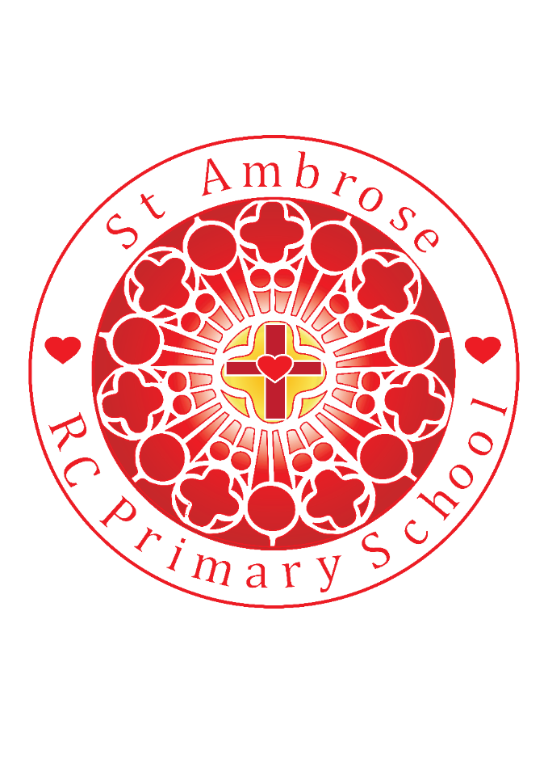

St Michael’s RC Primary School Weekly Newsletter

Loving Valuing Respecting

Diary dates

**After-school Sport**

3/9 - 21/12**:**

**Tu** Y5/6 Football

**Th** Y3/4 Multi skills

**December 2018**

**Fr 14th** PTA Christmas disco

**Mo 17th** KS2Christmas story 2:15pm

**Tu 18th** Christmas meal in Christmas Jumpers with uniform

Also Craft afternoon 2pm

**We 19th** Mini Vinnies leading Advent prayer stations in Church for whole school

**Th 20th** Party afternoon with suitable footwear and a warm coat please.

**Tuesday 18th Dec – Y4 will be watching the Y4 Nativity at St Bernadette’s**

**Whole School Mass Friday 21st December at 9.15am - All Parents and Families**  **welcome.**

**Advent Exposition in Church**

19th December 3.15pm

Pupil of the week – Well done!

R: Preston B for exceptional phonics

Y1: Jaiden T for listening so well at carpet time

Y2: Eva W for being a fantastic role model during our play

Y3: Marley M for learning the words & actions to our play so well

Y4: Sophia C for participating enthusiastically on our Roman day

Y5: Caitlyn S for all her kind and supportive efforts with her peers

Y6: Maciej D for excellent Christmas cake making

Lunchtime Superstars

N: Aoife W

R: Preston B

Y1: Nevaeh C

Y2: Hannah J

Y3: Theo G

Y4: Freya D

Y5: Kris S

Y6: Laila B

Well done everyone!

Well done to everyone!

**NEWS**

Friday 14th December 2018

Dear Parents,

As we enter the third week of Advent we focus on the **Joy** we feel as followers of Jesus. There has been great JOY shared this week within school, with joyful singing and stunning performances, sharing the special message of Jesus’ birth. ***Thank you Children!***

Thank you to all of our EYFS and KS1 children who performed so well during their Nativity plays this week. It was wonderful to see so many parents, families and friends at both events and for your generous donations to school. Thank you to all the staff who worked tirelessly behind the scenes in preparation for the performances. The children were a real credit to both their parents and teachers.

**Advent Service**

Thank you to all the children from Y3 from St Michael’s and St Bernadette’s who came together to remember the importance of Advent.

**CAFOD fundraising – Wearing Purple day**

Thank you for your contributions last Friday, £186 was raised. The Mini Vinnies will be choosing which World Gifts will best serve the communities that CAFOD support. They will let us all know next week.

**Poppy Appeal**

The British Legion have passed on their thanks for the amount of money raised this November by St Michael’s school, a total of £122.69 was collected. Thank you everyone!

**Craft Sale**

On **Tuesday 18th December at 2pm** we will be hosting craft stalls in the school hall. Each class has made exciting Christmas decorations and treats and will sell them on their class stall. The children will decide how to spend the money raised by their class. There will also be a cake stall, selling cakes and mince pies, to raise money for the charity ‘Mind’. All parents, carers and parishioners are welcome to join us from 2pm.

**Cakes and Cards**

Our Year 6 children will be distributing Christmas cakes and Cards that they have made to some of our St Michael’s parishioners, elderly and others in and around our school community next week. This is a wonderful way for the children to be witnesses of their faith, spreading the joy of Christmas to others.

**Advent Stations**

Each class will take part in Advent stations at St Michael’s Church on Wednesday 19th December, led by our Mini Vinnies. The activities at each station will enable the children to reflect in a unique and beautiful way about the importance of Advent. At one of the stations the children will join in the creation of a class card, these cards will be given as words of encouragement to the homeless and vulnerable people in Bury, in support of the Red Door charity, which is a Caritas project.

**Attendance** the whole school attendance for this week is 96.83%

**Statutory Tests Information Sessions for Parents/Carers - January 2019**

At the start of next term there will be SATs information sessions for parents in Years 2 and 6. There are two time slots for each year group.

Year Six will be inviting parents at 9.00am and at 4.00pm on Wednesday 9th January 2019.

Year Two will be welcoming parents at 9.00am and at 4.00pm on Tuesday 15th January 2019.

**St Michael’s Church - Exposition during Advent**

Exposition will be taking place in St Michael’s Church for the last time next week, on Wednesday 19th December.

There are two time slots, run by parishioners.

1) 3.15 pm till 4.15 pm. This is primarily for the parents, pupils and staff of the school but it is open to anyone

2) 5.00 pm till 6.00 pm. This is for everyone.

The parishioners of St Michael’s look forward to seeing as many children attending, with their families, to join in quiet prayer and reflection.

**PE Kits**

A reminder that children need to make sure that they have their P.E and Games kit in school on the allocated days.

**PARENT HUB REMINDER**

If you have not already please sign up to the Parent Hub app it is free to do so and it is a vital tool to keep up to date with things happening in school as well as publishing our weekly newsletter. Please call in to the school office for the app details.

Please note there is NO homework club on next week.

We hope everyone enjoys the PTA Christmas Disco this evening. Enjoy your weekend.

Thank you,

Mrs Bowes