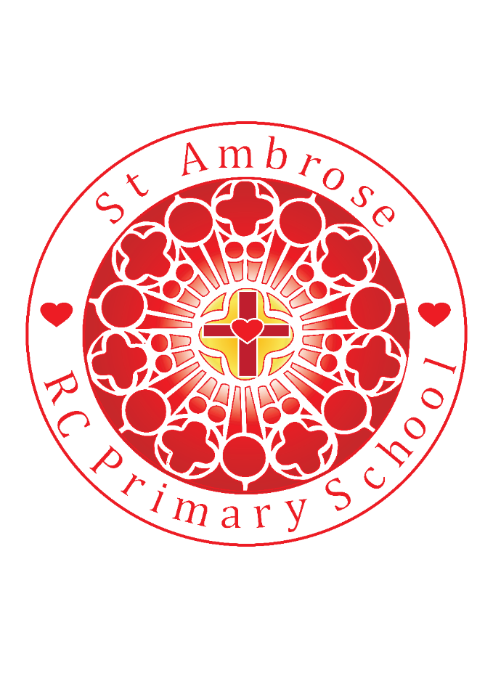

St Michael’s RC Primary School Weekly Newsletter

Loving Valuing Respecting

Diary dates

**Homework Club commences from 7th Jan**

**After-school Sports week commencing 14th Jan**

**Tu** Y5/6 Multi sports

**Th** Y1/2 Multi sports

**January 2019**

**Tue 8th SCIL** drop in sessions every Tuesday

**We 9th 9am & 4pm** Year 6 SATS information sessions

**Tu 15th 9am & 4pm** Year 2 SATS information sessions

**Su 13th 9:30am** Sacramental Meeting Mass

**Su 27th 9:30am** Sacramental Celebration Mass

.

**Stars of the Term – Well done!**

N: Freddie H

R: Isabella J

Y1: Joe M

Y2: Hannah J

Y3: Anthony H

Y4: Sophia C

Y5: Evie B

Y6: Emer K

**NEWS**

Friday 21st December 2018

Dear Parents,

**School Christmas Mass**

Thank you to all the children who sang so beautifully and joined in so reverently in our final Mass for this term, remembering this special time of year. Thank you to all the parishioners, family and friends of our school community who joined us today and Father Steven and Father Joe for officiating in this final Mass of 2018.

**KS2 Advent Gathering**

Thank you to all of our KS2 children who performed so well during the Advent Gathering celebration in Church. It was wonderful to see so many parents, families and friends. Thank you to all the staff who helped prepare the children for the celebration. The children were a real credit to both their parents and teachers.

**Advent Prayer stations**  
The Mini Vinnies led the prayer stations. They were very mature, guiding all the children from Nursery to Year 6, adapting their delivery to suit all the age groups.

There was a real sense of prayerfulness in Church. Children loved the opportunity to reflect at each station, engaging fully in the activities that were so creative and inspiring. Thank you to the Mini Vinnie team who made this experience for everyone in school so memorable. They certainly made their motto of ‘See, Think, Do’ come to life during this season of Advent. Well done!

**Craft-Afternoon**

Thank you to all the children who made fabulous Christmas gifts for the Craft afternoon in support of MIND. It was wonderful to see so many family and friends at the event. We raised a **terrific £431.70**. Thank you for contributing so generously.  
  
**New for January**

The SCIL (Supporting Communities Improving Lives) team can provide advice and support on various issues such as domestic violence, health/mental health, education, parenting, crime, housing, debt and benefits. Our aim is to link in with school in order to bridge the gap between education and home life. We can support both children and parents on either a one to one basis or as a collective. SCIL will be running a drop in at school every Tuesday whereby parents can receive advice and support and be signposted to the most appropriate service. This will commence from **Tuesday 8th January 2019.**  
  
  
**Awards**  
**Stars of the Autumn Term** have been chosen in each year group by their class teachers for showing an exemplary attitude to learning and impeccable behaviour towards other children and adults in school at all times.

**Attendance**

The whole school attendance for this Autumn term is 97%. Well done everyone!

**Statutory Tests Information Sessions for Parents/Carers - January 2019**

At the start of next term there will be SATs information sessions for parents in Years 2 and 6. There are two time slots for each year group.

Year Six will be inviting parents at 9.00am and at 4.00pm on Wednesday 9th January 2019.

Year Two will be welcoming parents at 9.00am and at 4.00pm on Tuesday 15th January 2019.

**PE Kits**

A reminder that when the children return in January that they **need** to have their P.E and Games kit in school on the allocated days.

**PTA Christmas Family Disco**

Thank you to all those who supported the PTA Christmas Disco – it was great to see so many children, families and friends. You raised a huge amount of £575.12!!

**PARENT HUB REMINDER**

If you have not already please sign up to the Parent Hub app it is free to do so and it is a vital tool to keep up to date with things happening in school as well as publishing our weekly newsletter. Please call in to the school office for the app details.

*The Children, Staff and Governors of St Michael’s wish all our families a very peaceful, holy and happy Christmas. We look forward to seeing you all in the New Year.*

*We start back on 7th January 2019.*

Mrs Bowes