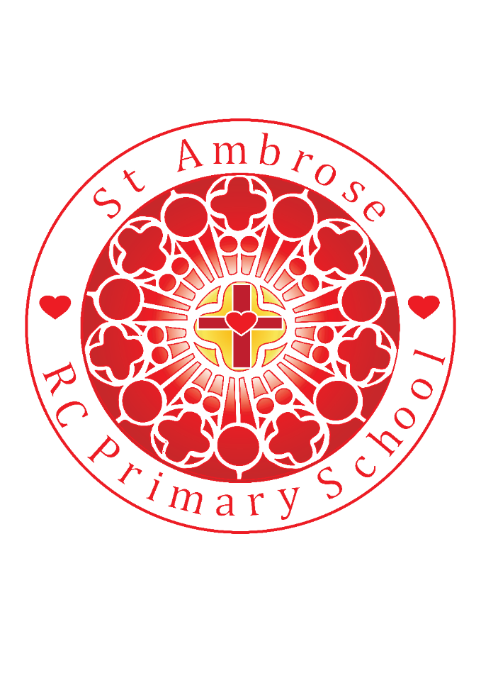

St Michael’s RC Primary School Weekly Newsletter

Loving Valuing Respecting

Diary dates

**Homework Club recommenced 7th Jan**

**3.15 – 4.15pm**

**After-school Sports week recommenced 14th Jan**

**Tu** Y5/6 Multi sports

**Th** Y1/2 Multi sports

**Mad Science**

We 6th Feb week 4 of 10

**February 2019**

Thur 14th Mosque visit Year 4

Fri 15th PGL final payment deadline

**Stars of the week – Well done!**

N: **Matilda A and Frankii G** for a great start to their new school

R: **Joshua H** for his fantastic retelling of the story ‘We’re Going on a Bear Hunt’

Y1: **Aoife W** for such lovely writing

Y2: **Jack P** for super writing about a scary creature

Y3**: Kiera K** for great enthusiasm in her maths work

Y4: **Maeve K** for always being ready and organised for working

Y5: **Mia C** for always working hard with a great big smile on her face

Y6: **Kilian K** for excellent fractions and decimals work

**Lunchtime Superstars – Well done!**

**N- Poppy D**

**R- Liberty-Beau D**

**Y1-Joe M**

**Y2- Evan K**

**Y3- Summer W**

**Y4- Tristan T**

**Y5- Declan B**

**Y6- Abbey**

**WW**

**NEWS**

Friday 1stth February 2019

Dear Parents,

**Sacramental Programme**

Thank you to all the children and families that attended the Celebration Mass last Sunday. The next Sunday Mass where the children will join together followed by a meeting is arranged for **Sunday 3rd March 2019.**

**Mini-Vinnies Spring Plans – Lenten mission work**

During the month of February the Mini Vinnies will be asking the children in school to bring in red bottle tops they might have at home to place in a box in the hall. These will help become part of badges for Red Nose Day.

**Attendance**

The whole school attendance for this week is 91%. Year 4 have the highest attendance this week at 96%. Well done!

**Speak out, Stay safe Assembly and Workshops**

Thank you to all the children who welcomed our special visitors from the NSPCC on Monday morning. The trained volunteers from the NSPCC led the Speak out Stay safe session which helped to equip our children with the knowledge and understanding they need to stay safe in the world today. They commented very positively on the children’s attitude to the assemblies and workshops, ***‘What a lovely morning we had, all of the children were so engaged, with such sensible attitudes from Years 5&6 when covering quite sensitive topics.’***

**National Story-telling Week**

National Story-telling week has been marked across school with all adults in school sharing fabulous stories with the children. The children have had the opportunity to welcome teachers from other classes, this has been wonderful to celebrate the importance of story-telling, enabling the children to listen to a different voice re-telling a new story. You will be able to see the pictures on our school website from next Monday.

**World Book Day** this year will be celebrated on Thursday 7th March, however we wanted to give you some information about how St Michael’s children will be invited to celebrate the day. The children will be involved in the design of a T-shirt, rather than the traditional dressing up. More details will follow after half term.

**Refurbishment of the KS2 Library**

The refurbishing of our KS2 library is now fully underway, with new furniture and books arriving to help create a new area which can be enjoyed by the children. The PTA successfully won a lottery bid last year, resulting in a £10,000 award for the project. We will be welcoming you all after half term to see the newly formed library.

We are hoping to raise some additional funds to paint and hopefully re-carpet the area to create a more inviting and welcoming Reading area for the KS2 children. This will involve the selling of some of our older books, which are still in reasonable condition, donations towards these books will help tremendously towards these additional costs! Some of our KS2 children will be selling the books before and after school next week in the KS1 playground. The children in school can also purchase books at breaktime in the school hall. We thank you for your continued support and look forward to sharing the pictures of the new library on the school website early next half term, once all the work is completed.

**Always Green Children**

Our ***Always Green*** children, including those who work really hard with a positive attitude to learning, will be nominated by their class teacher each week to share a hot chocolate treat/drink with Mrs Bowes. This week we welcome the following children:

Nursery: Darcy

Reception: Preston

Year 1: Julian

Year 2: Joshua

Year 3: Summer

Year 4: Henry

Year 5: Zack

Year 6: Michelle

**School Uniform**

Can we remind all children and parents/carers that black school shoes are to be worn in school and not coloured trainers or boots.

During this cold period can we ask all children to remember their hats, scarves and gloves.

**PE Kit**

All children should have their PE kit in school. If you have old kit (white t-shirts/black shorts or black leggings) that you no longer need, please donate it to school via the office.

**E-SAFETY Awareness**

At St Michael’s we take internet safety very seriously. We educate our children to stay safe and happy when online. E-Safety is taught discretely in classes and through whole school events and assemblies. We have Internet Safety day coming up on 5th February. On our website are links to support our young people and their families about safe use of technology, please take a look:

<https://www.thinkuknow.co.uk/>

<https://www.childnet.com/>

<http://www.bbc.co.uk/schools/0/computing/28972462>

There will be a **Parent Workshop at school from 3.30pm-4.30pm on Thursday 7th March**. All parents/carers are welcome to attend. It will be a really useful session that is shared with a number of schools in the borough.

Homework this week across the school involves a poster competition – please be as creative as you can to get the powerful message across to your audience!

**National Statutory Test Dates for 2019**

The following dates/time periods are set nationally for schools:

Year 6 - Monday 13th May to Thursday 16th May 2019

Year 2 – May 2019

Year 1 – Week commencing Monday 10th June 2019

**SCIL TEAM**

The SCIL (Supporting Communities Improving Lives) team can provide advice and support on various issues such as domestic violence, health/mental health, education, parenting, crime, housing, debt and benefits. Our aim is to link in with school in order to bridge the gap between education and home life. We can support both children and parents on either a one to one basis or as a collective. SCIL will be running a drop in at school every Tuesday whereby parents can receive advice and support and be signposted to the most appropriate service. Gemma Lane from SCIL will be in school each **Tuesday. Please call into the school office if you have any queries or questions relating to this service.**

We wish you a happy, safe and restful weekend. Thank you for your continued support especially this week with the snowy weather that arrived.

Mrs Bowes