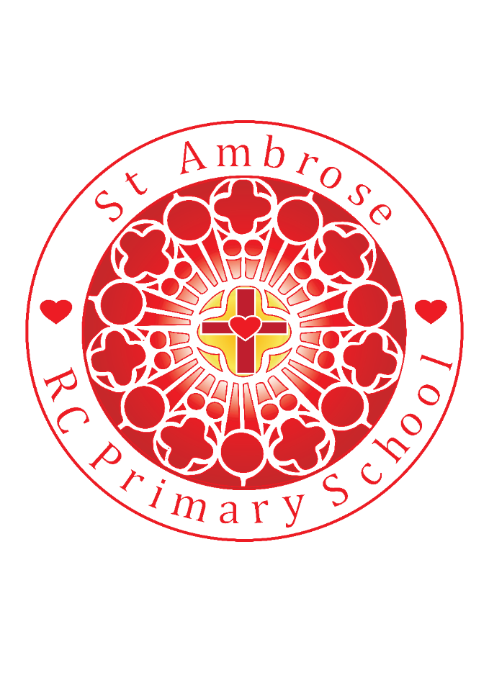

St Michael’s RC Primary School Weekly Newsletter

Loving Valuing Respecting

Diary dates

**Homework Club recommenced 7th Jan**

**3.15 – 4.15pm**

**After-school Sports week recommenced 14th Jan**

**Tu** Y5/6 Multi sports

**Th** Y1/2 Multi sports

**Mad Science**

We13th Feb week 5 of 10

**February 2019**

Thur 14th Mosque visit Year 4

Fri 15th PGL final payment deadline

Fri 15th Y2 and Y5 Mass @ 10am

**March 2019**

Fri 15th N and R Mass @ 10am

Fri 22nd Y1 and Y4 @10am

**Stars of the week – Well done!**

N: **Jake H** for a great start to his new school

R: **James C** for fantastic sounding out and writing

Y1: **Harvey M** for good reading

Y2: **Tilly A** for always reading at home and listening in class

Y3**: Brandon L** for always being ready to learn, always smiling and setting a good example to Year 3

Y4: **Christian B** for a good improvement in his presentation especially in Maths

Y5: **Aaron J** for a great clay animal sculpture

Y6: **Seren L** for showing great resilience

**Lunchtime Superstars – Well done!**

**N- Gracie A**

**R- Grace P**

**Y1-Maisie M**

**Y2- Darcey M**

**Y3- Gabriel A**

**Y4- Tristan T**

**Y5- Amari D**

**Y6- Maciej D**

**NEWS**

Friday 8th February 2019

Dear Parents,

**Mini-Vinnies Spring Plans – Lenten mission work**

During the month of February the Mini Vinnies will be asking the children in school to bring in red bottle tops they might have at home to place in a box in the entrance hall. These will help become part of badges for Red Nose Day.

The Mini Vinnies are also collecting kitchen rolls, toilet rolls and tissues during the month of February.

**Attendance**

The whole school attendance for this week is 97%. Year 5 have the highest attendance this week at 98%. Well done!

**World Book Day** this year will be celebrated on Thursday 7th March, however we wanted to give you some information about how St Michael’s children will be invited to celebrate the day. The children will be involved in the design of a T-shirt, rather than the traditional dressing up. More details will follow after half term.

**School Uniform**

Can we remind all children and parents/carers that black school shoes are to be worn in school and not coloured trainers or boots.

During this cold period can we ask all children to remember their hats, scarves and gloves.

**PE Kit**

All children should have their PE kit in school. If you have old kit (white t-shirts/black shorts or black leggings) that you no longer need, please donate it to school via the office.

**E-SAFETY Awareness**

Thank you to all the fabulous entries for Internet Safety Day. Well done everyone.

At St Michael’s we take internet safety very seriously. We educate our children to stay safe and happy when online. E-Safety is taught discretely in classes and through whole school events and assemblies. On our website are links to support our young people and their families about safe use of technology, please take a look:

<https://www.thinkuknow.co.uk/>

<https://www.childnet.com/>

<http://www.bbc.co.uk/schools/0/computing/28972462>

There will be a **Parent Workshop at school from 3.30pm-4.30pm on Thursday 7th March**. All parents/carers are welcome to attend. It will be a really useful session that is shared with a number of schools in the borough.

**Always Green Children**

Our ***Always Green*** children, including those who work really hard with a positive attitude to learning, will be nominated by their class teacher each week to share a hot chocolate treat/drink with Mrs Bowes. This week we welcome the following children:

Nursery: Jaxson

Reception: Eva

Year 1: Olivia

Year 2: Luke

Year 3: Kaelo

Year 4: Ciara

Year 5: Zack

Year 6: Michelle

**A Message from St Michael’s Hall**

Ceilidh at St Michael's Hall Saturday 2nd March Saturday 2nd March 7.30 - Midnight. Irish/Folk music with DJ - JIB . Tickets £5 includes light refreshments.

Tickets will be on sale before/after each mass at both churches or from Angela 0161 796 2128 or Mary 0161 797 3312

Thanks very much

We wish you a happy, safe and restful weekend. Thank you for your continued support.

Mrs Bowes