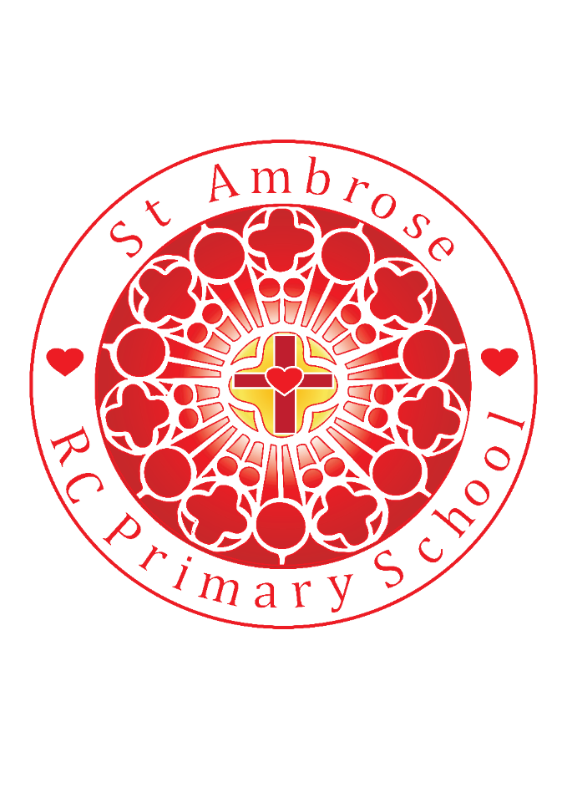

St Michael’s RC Primary School Weekly Newsletter

Diary dates

**Homework Club Mo 13th May**

3.15 – 4.15pm

**After-school Sports**

Tu Y3/4 Multi sports

Th Y1/2 Multi sports

**MAY 2019**

Su 19th Sacramental Programme Mass and Meeting

Mo 20th Rounder’s Rally 1

**JUNE 2019**

Mo 3rd Y5 swimming 4 weeks

Tu 4th Y5 swimming 4 weeks

Th 13th Scooters

Sa 15th First Holy Communion 11am and 2pm

Tu 18th Y5 Road Safety

Su 23rd Sacramental Programme Celebration

Mo 24th Rounders Rally 2

24th & 25th Y6 Bikeability

26th June Y6 Secondary open day

27th & 28th Y6 Bikeability

Thu 27th Gabriel Cup Athletics Competition

Fr 28th Rec Balance ability

Su 30th Year 2 Introduction Sacramental programme

**LUNCHTIME SUPERSTARS**

**N: Nikolai**

**R: Henry**

**Y1: Alfie**

**Y2: Malachy**

**Y3: Gabriel**

**Y4: Tristan**

**Y5: Mia**

**Y6: Roksana**

**PUPILS OF THE WEEK**

**N: Weronika for coming so positively into school**

**R: Noah for fantastic imagination on our school trip**

**Y1: Eliza for being such a lovely new friend**

**Y2: Avah-Mai for trying hard in her Maths work**

**Y3: Marcus for great behaviour and being hard working**

**Y4: Ollie for such polite manners and exemplary behaviour**

**Y5: Jeramiah for excellent input into our writing session**

**Y6: Matthew for being enthusiastic during revision**

**WELL DONE EVERYONE!!**

**Y6**

**NEWS**

Loving Valuing Respecting

Friday 3rd May 2019

Dear Parents,

During this month of May we remember Mary – the mother of Jesus, who we know as the Queen of heaven. She rejoices with us at the news of Jesus rising on Easter Sunday.

[](https://www.google.com/url?sa=i&rct=j&q=&esrc=s&source=images&cd=&cad=rja&uact=8&ved=2ahUKEwih_Jjx_f7hAhUky4UKHeeaDncQjRx6BAgBEAU&url=https://www.americaneedsfatima.org/Our-Blessed-Mother/may-the-month-of-mary.html&psig=AOvVaw20XQXrUhRCsDYRUpJ1J0c5&ust=1556959922654394)

In this month of May we are focusing on the value of ***Caring*** for others and the world around us. This fits in perfectly with the Pope’s call to us all to look after our environment and the work of the Mini Vinnies.

The Head Teachers award this week goes to Summer **in Year 3** for showing **Outstanding Behaviour for Learning**. Thank you Summer.

**Always Green Children**

Our *Always Green* children this week are:

Nursery: Weronika , Reception: Charlie, Year 1: Zara, Year 2: Tyler, Year 3: Adam, Year 4: Olivia T, Year 5: Ole and Year 6: Emer

Well done to all the children!

**Attendance**

The whole school attendance for this week is 95.72%. Year 6 has the highest with 100%!! Well done Year 6!

**Sports News**

Well done to the Boys Football Team this week – they played two matches in one day! All the boys behaved in an exemplary manner. They won their match against St Bernadette’s scoring some superb goals! Well done to you all!

**Uniform**

Our school uniform aims to create a sense of belonging and raises the profile of the school image. Therefore we would like to remind parents that we have very clear expectations. Attached to this newsletter is our School Uniform Policy and it is also available on the school website. Please can we ensure that all of our children are dressed in the appropriate uniform. We thank-you for your continued support & co-operation.

**Reception trip to Imagine That!**

Our Reception children visited Liverpool’s Science and Discovery Centre on Tuesday this week. They had a fabulous experience – the children experimented with lots of new materials, found themselves head to toe in sand and had quite an exhausting day! Thank you to all the staff who made the trip a success. There are a number of pictures on our Reception Class page – please take a look.

**Mini-Vinnies Collection**

To contribute to the Red Door Centre during the month of May, we would welcome **bath and shower products. Please give generously for this local and good cause.**

**CAFOD Recycling Project -**Thank you to all those who have made ‘eco-bricks’ at home and have brought them in to support our school vision to create pieces of outdoor furniture. To make an eco-brick, clean dry single-use plastic is pushed into a bottle e.g 2 litre lemonade bottle and compressed until it weighs approximately 660grams. Please continue to bring them in – we need lots more!!!

**Maths Workshop – A date for your diary!**

On **Monday 20th May** Mrs Howe will be running a Maths Workshop focusing on Fractions. There will be two workshops throughout the day, the first will be held at 9.00am and the second at 2.30pm. The sessions will run for approximately 30 minutes. All parents/carers are very welcome to attend and it would be great to see you there.

**Cake Sale – Thank you everyone!**

Thank you to everyone who has contributed so generously to the cake sale today. Our organisers have worked hard to make it a success too. A very big thank you to everyone who is part of our school community – you always give so generously!

**Sacramental Programme Meeting for Year 2 Parents/Carers**

There will be a meeting for all parents/carers from our current Year 2 class on **Sunday 30th June at 12.30pm** in St Bernadette’s School Hall. The meeting will introduce you all to the important Sacramental Programme journey information and will give you an opportunity to ask any questions about the arrangements for the year ahead.

**PGL Meeting for Y6 Parents/Carers**

Miss Grundy will be leading a meeting for all those attending PGL at the end of May. The meeting will take place on **Wednesday 8th May at 3.30pm** in our Y6 classroom We will be sharing the important arrangements for the residential visit and it will be opportunity to ask any questions you may have regarding the trip.

**Year 3 Class Choir -** Our Year 3 class have been selected to take part in a Massed Sing Day at Unsworth County Primary School with a number of other schools on **Tuesday 11th June**. The event will take place from 1.30pm and parents are welcome to come and watch. A further letter will be sent to all Y3 parents/carers confirming the arrangements for the afternoon. Please put the date in your diary!

Thank you for your ongoing support and enjoy the extra day this weekend! See you all on Tuesday 7th May.

Mrs Bowes

It is our School Policy that all children wear the School Uniform as listed below in KS1 and KS2.

|  |  |
| --- | --- |
| **Boys** | **Girls** |
| -Navy blue sweatshirt with School logo  -White Polo shirt  -Dark grey (Charcoal) trousers/shorts  -Sensible and plain Black shoes or Black plain, smart trainers (without logos)  -Plain black/grey socks | -Navy blue sweatshirt/Cardigan with School logo  -White Polo shirt  -Dark grey (Charcoal) trousers  -Dark grey (Charcoal) skirt/pinafore  -Sensible and plain Black shoes or Black plain/smart trainers (no boots or heels) and without logos  -Plain white socks or black tights  **Summer:**  Blue gingham style dresses |

**PE Kit:**

Plain Black/Navy Shorts

Plain White T-shirt/Polo shirt

Plain Black Pumps and Trainers for Outdoor Games. If outside sports in cold weather plain black/navy jogging bottoms (No logos).

**EYFS – 2019 – Nursery and Reception**

|  |  |
| --- | --- |
| **Boys** | **Girls** |
| -Red sweatshirt with School logo  -White Polo shirt  -Dark grey (Charcoal) trousers/shorts  -Sensible and plain Black shoes or Black plain/smart trainers and without logos  -Plain black/grey socks | -Red sweatshirt/Cardigan with School logo  -White Polo shirt  -Dark grey (Charcoal) trousers  -Dark grey (Charcoal) skirt/pinafore  -Sensible and plain Black shoes or Black plain/smart trainers (no boots or heels) and without logos  -Plain white socks or black tights  **Summer:**  Red gingham style dresses |

**PE Kit for Reception:**

Plain Black/Navy Shorts

Plain White T-shirt/Polo shirt

Plain Black Pumps and Trainers for Outdoor Games. If outside sports in cold weather plain black/navy jogging bottoms (No logos).